qutFACULTY OF SCIENCE AND ENGINEERING

SEMESTER 2, 2016

**IAB330: Mobile App Development**

**Assignment 2: App Prototype**

**Due Date:** 28 October 2016 – Week 13 Friday

**Assignment is submitted as a team using Blackboard**

**Weight: 50%**

DECLARATION

You must sign below. By signing this form you agree to the following:

* We declare that all of the work submitted for this assignment is our own original work except for material that is explicitly referenced and for which we have permission, or which is freely available (and also referenced)
* We agree that QUT may archive this assignment for an indefinite period of time, and use it in the future for educational purposes including, but not limited to: as an example of previous work; as the basis for assignments, lectures or tutorials; for comparison when scanning for plagiarism, etc.
* We agree to indemnify QUT and hold it blameless if copyright infringements are found in this work and the copyright owner takes action against QUT that is not covered by the normal terms of Educational Use.

The assignment shall be conducted in a team of 2-4 students, each team member must sign as it is a formal agreement that represents that everyone is contributing to the whole assignment.

|  |  |  |
| --- | --- | --- |
| **Team Member Details** | | |
| **Student Number** | **Student Name** | **Signature** |
| N9552286 | Yew Lren Chong |  |
| N9350179 | Jes Shern Thing |  |
| N9532897 | Tee Ken Lau |  |
| N9293400 | Jianing Chang |  |

**Important Details**

Bitbucket URL: <https://bitbucket.org/shiftmybits/telstraapp>

Bitbucket Clone HTTPS: <https://yewlrenchong@bitbucket.org/shiftmybits/telstraapp.git>

Branch name: Assignment_2_ShiftMyBits

*We have added [joshua.wallace@team.telstra.com](mailto:joshua.wallace@team.telstra.com) to the team repository.

Must Have Features Completed:

* Request status of colleague
* Send status/location (as much info as requestee would like to send)
* Easy interface/ Interact direct via notification

High Performance Feature:

* Azure Mobile App Service (Database)
* Azure Mobile App Service (Database + Notification Hub)
* Location Awareness (Google Play Services)

**User Acceptance Test Report**

User stories, Acceptance Criteria and Test Cases were discussed and written by all team members.

Tester: Chen Hua Lu (N9543503)

Email: [chenhua.lu@connect.qut.edu.au](mailto:chenhua.lu@connect.qut.edu.au)

Phone: 0478843585

*Green Highlight Signifies Passed, Red Highlight Signifies Failed.

**“Search” Feature**

|  |  |  |  |  |
| --- | --- | --- | --- | --- |
| **User Story** | **Acceptance Criteria** | **Test Cases** | **PASSED** | **FAILED** |
| **As a user**,  **I want** to search for staff using keywords such as first name, last name, or department,  **So that** I can get suggestions and complete my search faster. | **1.** A suggestion list of contacts drops down when I begin typing a name.  **2.** A suggestion list of contacts drops down when I begin typing the name of a department. | **Test Case 1**  Given when I am on the search page, when I type a name in the search field;  **Expected Result:**  Then I should see a suggestion list with full name and department shown. |  |  |
| **Test Case 2**  Given when I am on the search page, when I type a department in the search field;  **Expected Result:**  Then I should see a list of all staff from the department. |  |  |
| **Test Case 3**  Given when I am on the search page, when I type my own name in the search field;  **Expected Result:**  Then I should not see a suggestion of my own name. |  |  |

**“Request” Feature**

|  |  |  |  |  |
| --- | --- | --- | --- | --- |
| **User Story** | **Acceptance Criteria** | **Test Cases** | **PASSED** | **FAILED** |
| **As a user**,  **I want** to be able to send a notification,  **So that** the respondent can be notified. | **1.** The user will be able to send a request to the respondent from the **“Search”** page.  **2.** The user will be able to send a request to the respondent from the **“Recent”** page.  **3.** The user will be able to send a request to the respondent from the **“Favourite”** page. | **Test Case 1**  **Preconditions:**  Given when I am on the search page,  **Steps to Reproduce:**  When I type in a name,  And selected it from the suggestion list,  And I press Yes to confirm the request,  **Expected Result:**  Then I should see a confirmation dialogue box showing **“Request Sent”.** |  |  |
| **Test Case 2**  **Preconditions:**  Given when I am on the search page,  **Steps to Reproduce:**  When I type in a name,  And selected it from the suggestion list,  And I press No to reject the request,  **Expected Result:**  The dialogue box should disappear and I will return to the search page with an empty search text box. |  |  |
| **Test Case 3**  **Preconditions:**  Given when I am on the **“Recent”** page,  **Steps to Reproduce:**  When I select a name from the list,  And I press the **“Request Location”** button,  And I press Yes to confirm the request,  **Expected Result:**  Then I should see a confirmation dialogue box showing **“Request Sent”.** |  |  |
| **Test Case 4**  **Preconditions:**  Given when I am on the **“Recent”** page,  **Steps to Reproduce:**  When I select a name from the list,  And I press the **“Request Location”** button,  And I press No to reject the request,  **Expected Result:**  The dialogue box should disappear and I will return to the **“Recent”** page with a list of my recent contacts. |  |  |
| **Test Case 5**  **Preconditions:**  Given when I am on the **“Favourites”** page,  **Steps to Reproduce:**  When I select a name from the list,  And I press the **“Request Location”** button,  And I press Yes to confirm the request,  **Expected Result:** Then I should see a confirmation dialogue box showing **“Request Sent”.** |  |  |
| **Test Case 6**  **Preconditions:**  Given when I am on the **“Favourites”** page,  **Steps to Reproduce:**  When I select a name from the list,  And I press the **“Request Location”** button,  And I press No to reject the request,  **Expected Result:**  The dialogue box should disappear and I will return to the **“Favourites”** page with a list of my favourite contacts. |  |  |

**“Reply” Feature**

|  |  |  |  |  |
| --- | --- | --- | --- | --- |
| **User Story** | **Acceptance Criteria** | **Test Cases** | **PASSED** | **FAILED** |
| **As a Respondent**,  **I want** to be able to select the type status that I would like to send to the Requester**;**  **So that** I can control the type of response that will be sent to the Requester. | **1.** The Respondent is able to select the type of status; location, availability or both, which will trigger different responses to the Requester. | **Test Case 1**  **Preconditions:**  Given when someone has requested my status,  And I received a notification, And I tap on the notification,  And I am on the Respondent View Page,  **Steps to Reproduce:**  When I only tick the location checkbox,  And I tap send,  **Expected Result:**  Then I should see a dialogue box showing “Request Sent”, and I will return to the Search Page. |  |  |
| **Test Case 2**  **Preconditions:**  Given when someone has requested my status,  And I received a notification, And I tap on the notification,  And I am on the Respondent View Page,  **Steps to Reproduce:**  When I only tick the Availability checkbox  And I tap send,  **Expected Result:**  Then I should see a dialogue box showing “Request Sent”, and I will return to the Search Page. |  |  |
| **Test Case 3**  **Preconditions:**  Given when someone has requested my status,  And I received a notification, And I tap on the notification,  And I am on the Respondent View Page,  **Steps to Reproduce:**  When I do not tick any checkboxes,  And I tap on Send,  **Expected Result:**  Then I should see a dialogue box showing “Request Sent”, and I will return to the Search Page. |  |  |
| **Test Case 4**  **Preconditions:**  Given when someone has requested my status,  And I received a notification, And I tap on the notification,  And I am on the Respondent View Page,  **Steps to Reproduce:**  When I tap on Cancel,  And I confirm the cancellation,  **Expected Result:**  Then I will be returned to the Search Page. |  |  |
| **Test Case 5**  **Preconditions:**  Given when someone has requested my status,  And I received a notification, And I tap on the notification,  And I am on the Respondent View Page,  **Steps to Reproduce:**  When I tap on Cancel,  And I reject the cancellation,  **Expected Result:**  Then I will remain on the Respondent View Page. |  |  |

**“Response” Feature**

|  |  |  |  |  |
| --- | --- | --- | --- | --- |
| **User Story** | **Acceptance Criteria** | **Test Cases** | **PASSED** | **FAILED** |
| **As a Requester**,  **I want** to receive a notification from the Respondent;  **So that** I am able to view the status that the Respondent has selected. | **1.** As a Requester, I want to receive a respond based on the Respondent’s selection of status. | **Test Case 1**  **Preconditions:**  Given my phone is idle or standby,  **Steps to Reproduce:**  When someone has responded to my request,  And they have selected to respond with both Location And Availability,  And I tap on the notification,  **Expected Result:**  Then I should be on the Respond page which shows the Respondent’s name, their location and availability, and the options to Call, Send a Message, or a Back option. |  |  |
| **Test Case 2**  **Preconditions:**  Given my phone is idle or standby,  **Steps to Reproduce:**  When someone has responded to my request,  And they have selected to respond with only Location,  And I tap on the notification,  **Expected Result:**  Then I should be on the Respond page which shows the Respondent’s name and their location only, together with the options to Call, Send a Message, or a Back option.  **Test Case 3**  **Preconditions:**  Given my phone is idle or standby,  **Steps to Reproduce:**  When someone has responded to my request,  And they have selected to respond with only Availability,  And I tap on the notification,  **Expected Result:**  Then I should be on the Respond page which shows the Respondent’s name and their Availability only, without their Location, together with the options to Call, Send a Message, or a Back option. |  |  |

**“Notification” Feature**

|  |  |  |  |  |
| --- | --- | --- | --- | --- |
| **User Story** | **Acceptance Criteria** | **Test Cases** | **PASSED** | **FAILED** |
| **As a user**,  **I want** to receive notifications;  **So that** I can be notified when someone has requested for my status. | **1.** A notification will appear on the user’s phone when someone has requested his/her status. | **Test Case 1**  **Preconditions:**  Given my phone is idle or standby,  **Steps to Reproduce:**  When someone has requested my status,  **Expected Result:**  Then I should receive a notification at any given time. |  |  |
| **As a Requester,**  **I want** to receive a reply notification from the respondent;  **So that** I can find out their location and availability. | **1.** A notification will appear on the **Requester’s** phone when someone has responded to their request. | **Test Case 2**  **Preconditions:**  Given my phone is idle or standby,  **Steps to Reproduce:**  When someone has responded to my request,  **Expected Result:** Then I should receive a notification at any given time. |  |  |

**“Recent History” Feature**

|  |  |  |  |  |
| --- | --- | --- | --- | --- |
| **User Story** | **Acceptance Criteria** | **Test Cases** | **PASSED** | **FAILED** |
| **As a user**,  **I want** to be able to have a Recent page;  **So that** I can see who I have contacted and who has contacted me in the past. | **1.** When the user has confirmed to request the status from a selected user, the selected user and a timestamp will appear in the Recent page.  **2.** When another user has requested the status from the first user, the requester and a timestamp will appear in the Recent page. | **Test Case 1**  **Preconditions:**  Given I have requested for someone’s status before  Or someone has requested for my status in the past,    **Steps to Reproduce:**  When I am on the Recent page,  **Expected Result:** Then I should see a history of contacts whom I have sent or receive status based on the timestamp. |  |  |
| **Test Case 2**  **Preconditions:**  Given I am on the Search page,  **Steps to Reproduce:**  When I perform a new status request,  And I go to the Recent Contact page,  **Expected Results:** Then I should see the newest contact listed in the Recent Contact page with a timestamp. |  |  |
|  |  | **Test Case 3**  **Preconditions:**  Given I am on the Favourite page,  **Steps to Reproduce:**  When I perform a new status request,  And I go to the Recent Contact page,  **Expected Results:** Then I should see the newest contact listed in the Recent Contact page with a timestamp. |  |  |

**“Favourites” Feature**

|  |  |  |  |  |
| --- | --- | --- | --- | --- |
| **User Story** | **Acceptance Criteria** | **Test Cases** | **PASSED** | **FAILED** |
| **As a user**,  **I want** to have a Favourite page where I can view all my favourite contacts,  **So that** it is easier for me to access them. | **1.** When the user has chosen to add a contact as favourites, that contact will show up in the Favourites Page. | **Test Case 1**  **Preconditions:**  Given I have chosen several contacts as Favourites,  **Steps to Reproduce:**  When I have tap on the Favourite button,    **Expected Result:**  The user I have selected should appear in the Favourites page. |  |  |

**UI Assets**

**Version 1**

**App Screenshots**

Search View

Favourites View

Recent / History View

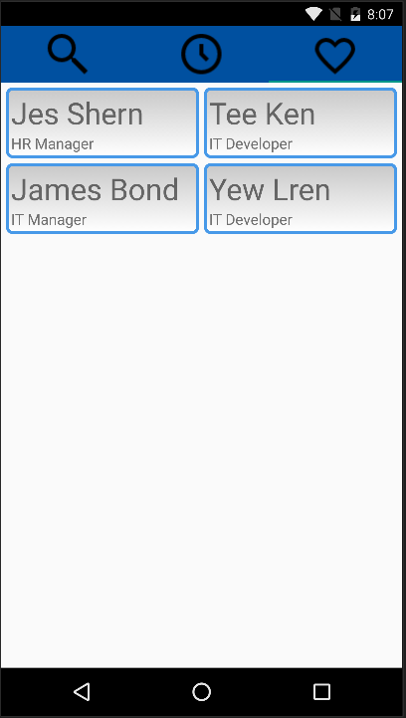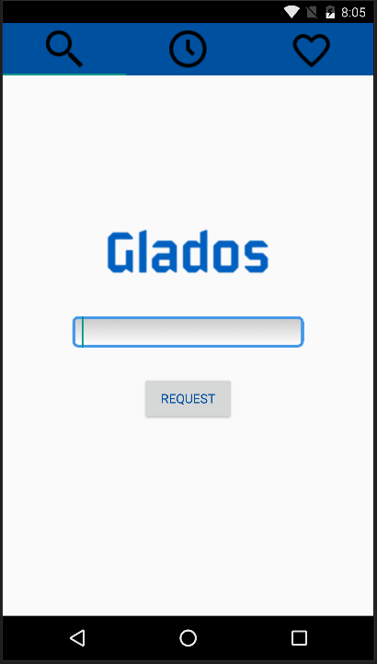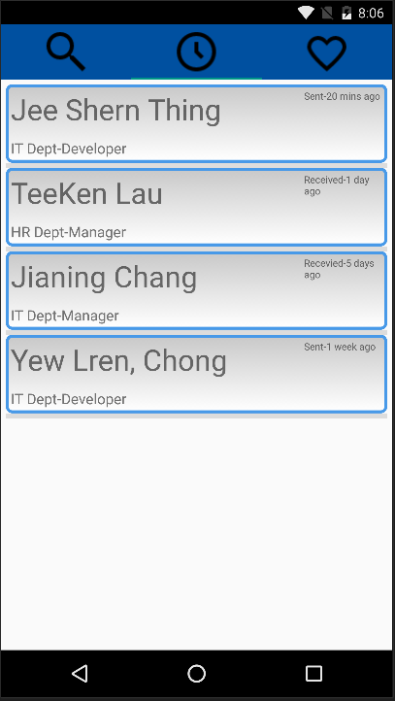

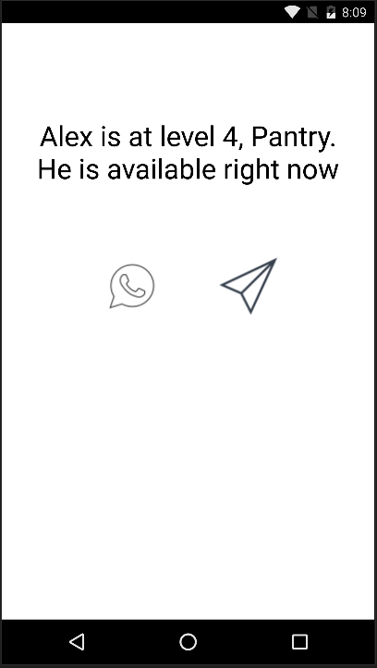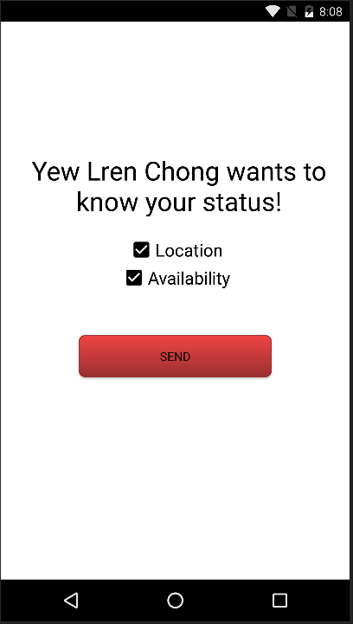

**Response View**

**Respondent View**

**Version 2 (Final)**

**App Screenshots**

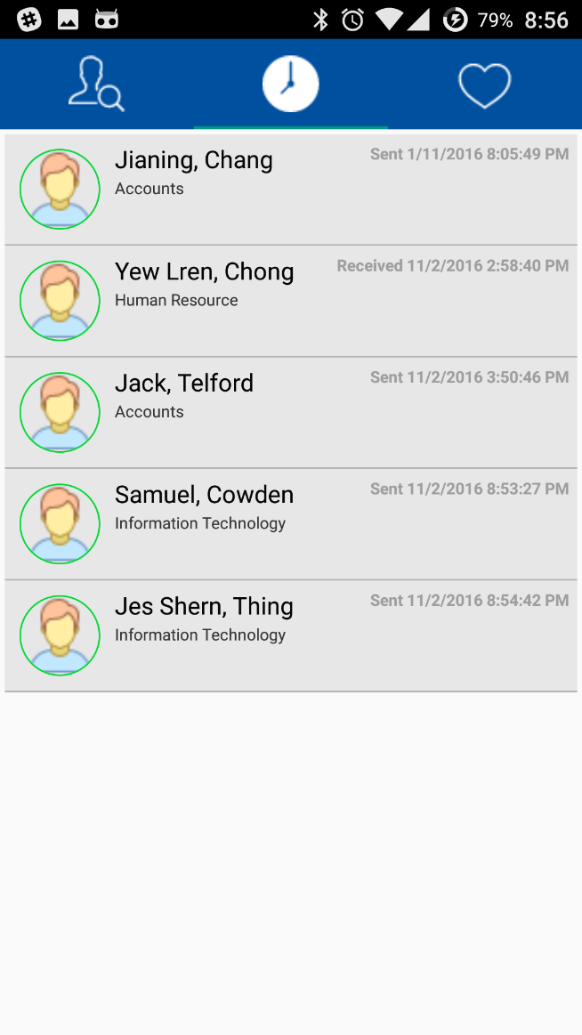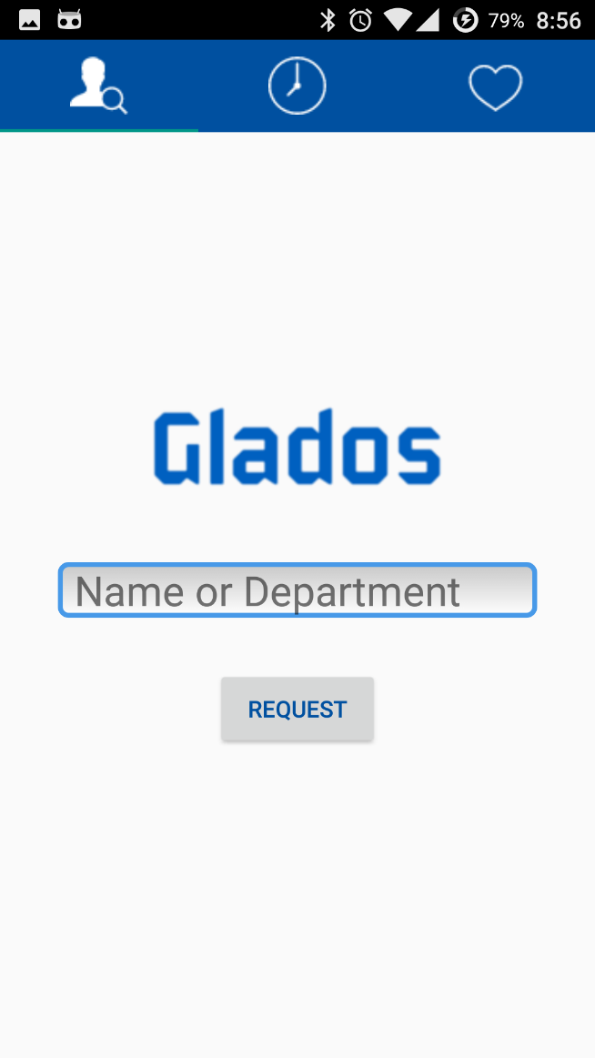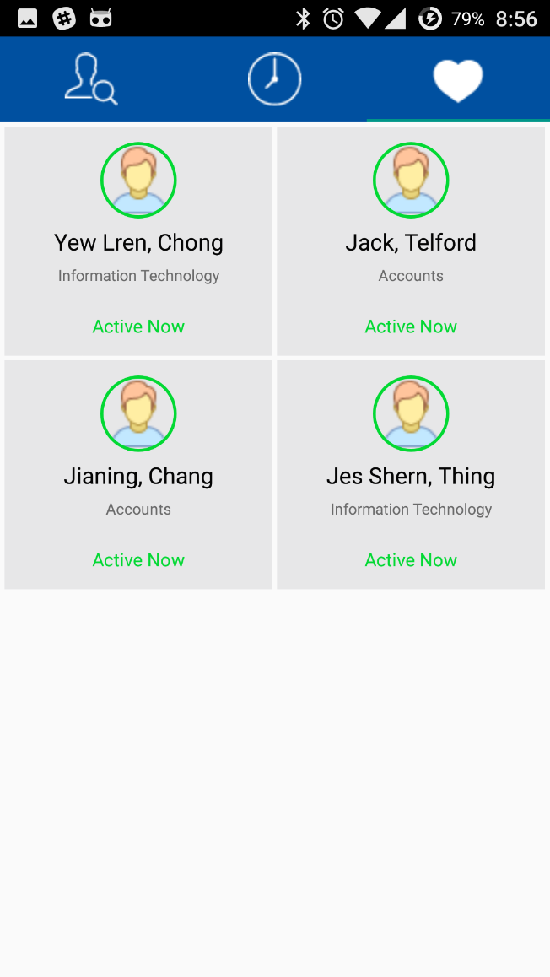

Favourites View

Recent View

Search View

Splash-screen

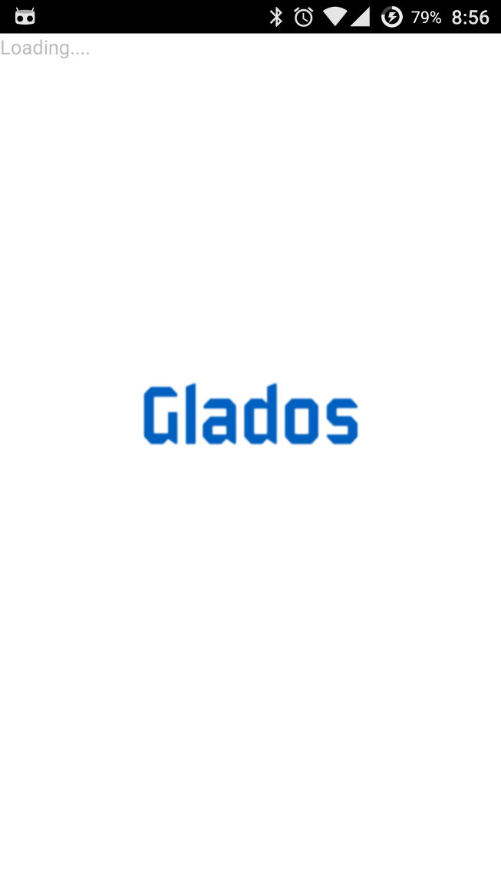

Request Notification

Response Notification

Response View

Respondent View

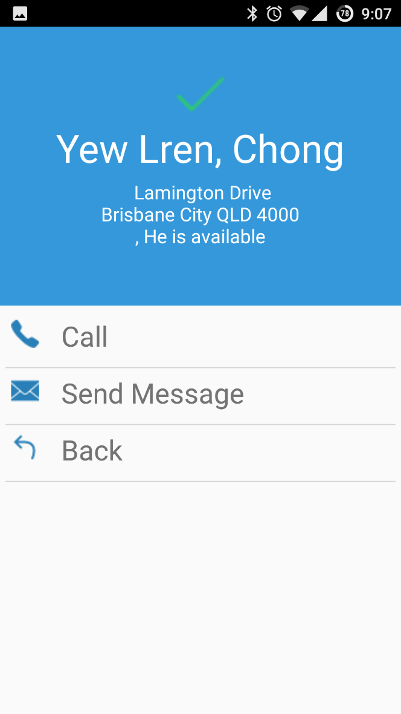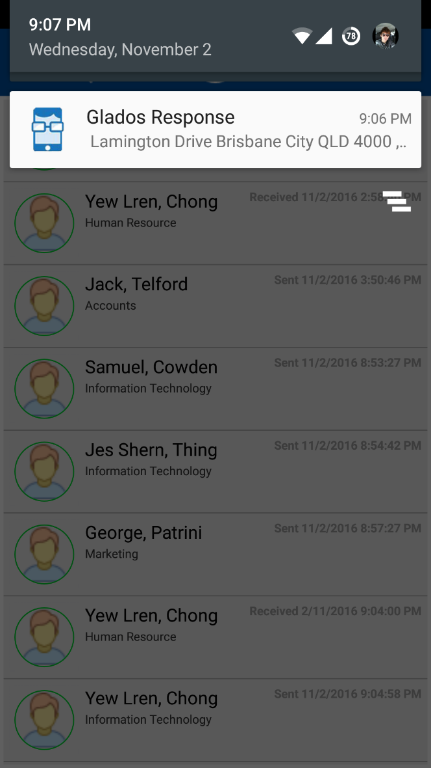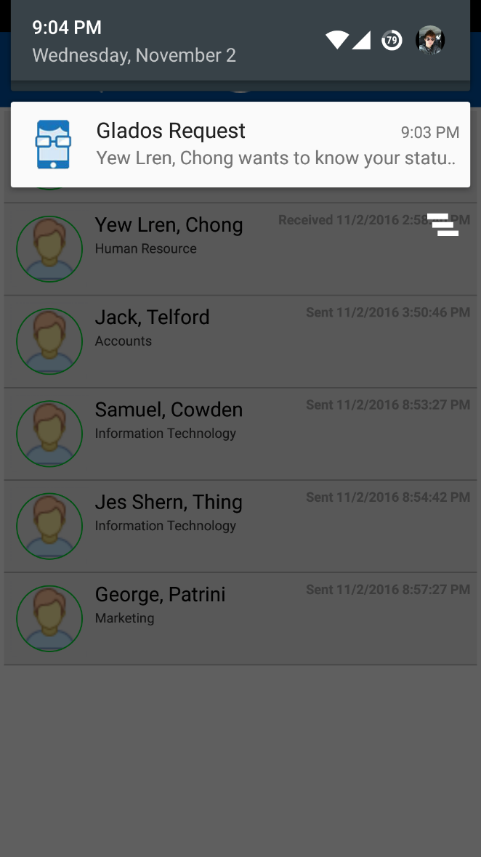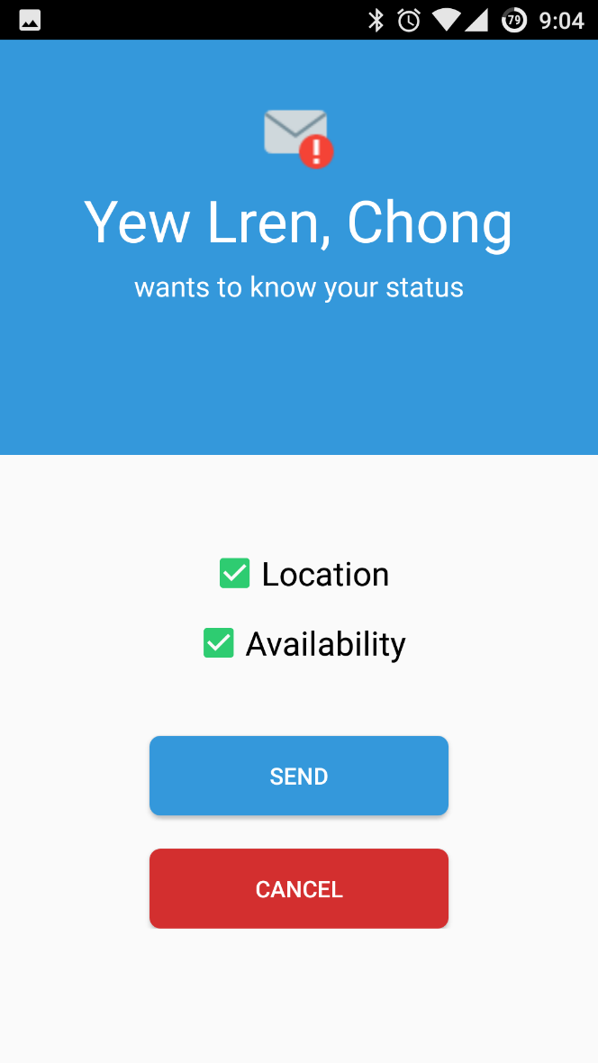

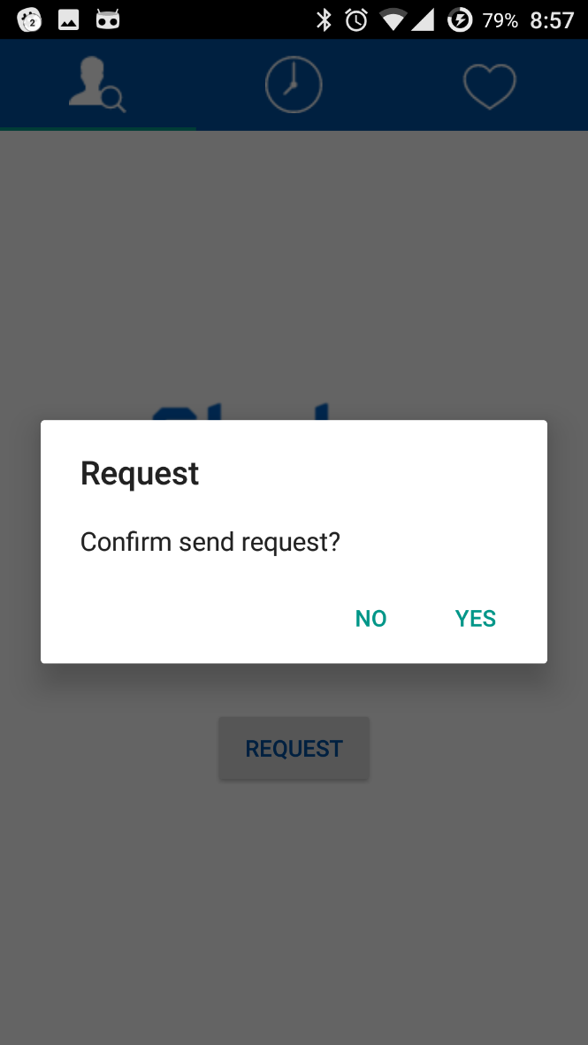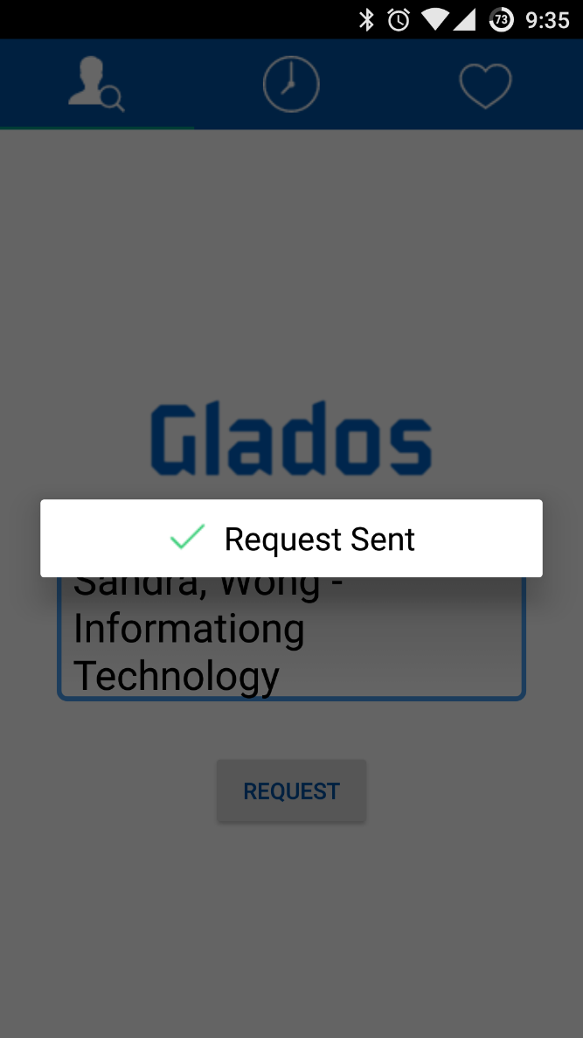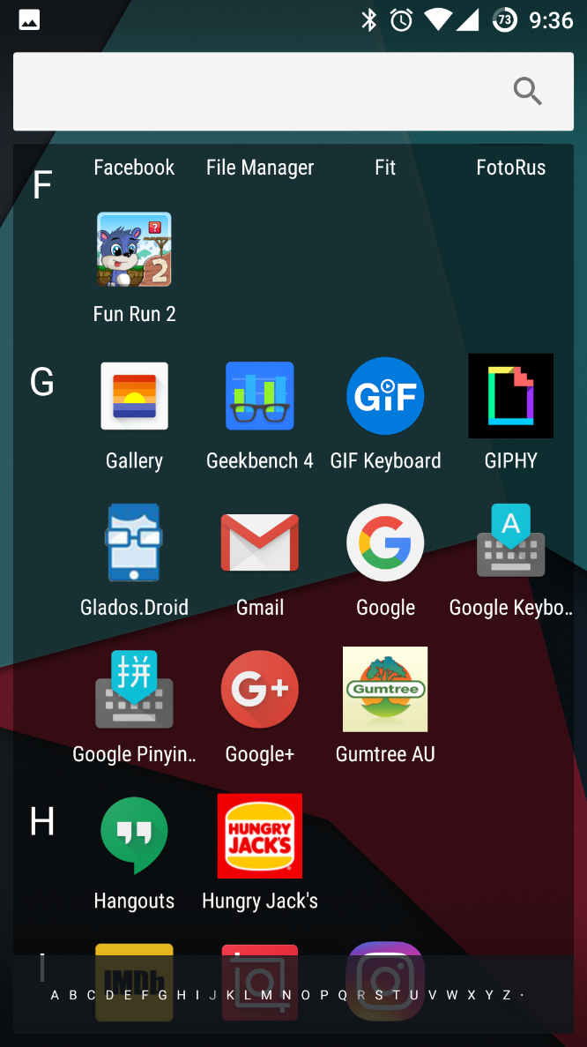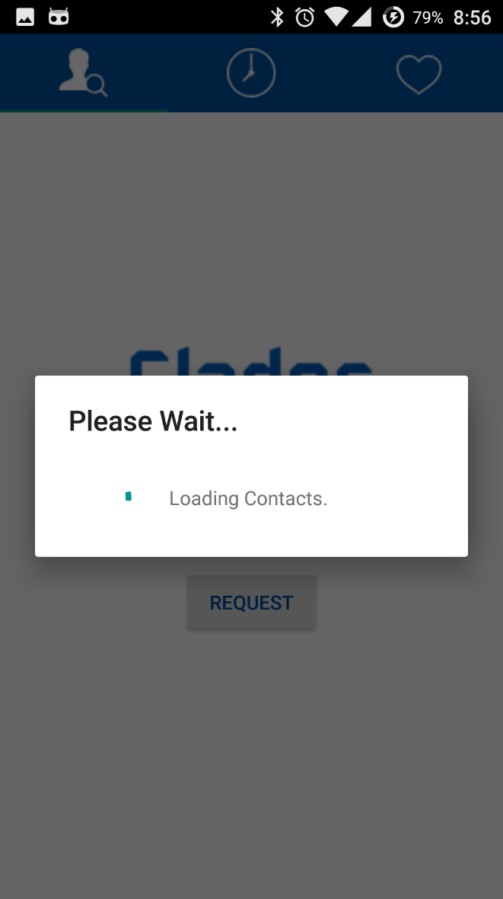

Glados Icon

Confirmation Dialog

Loading Spinner Dialog

Request Confirmation Dialog

**Project Plan**

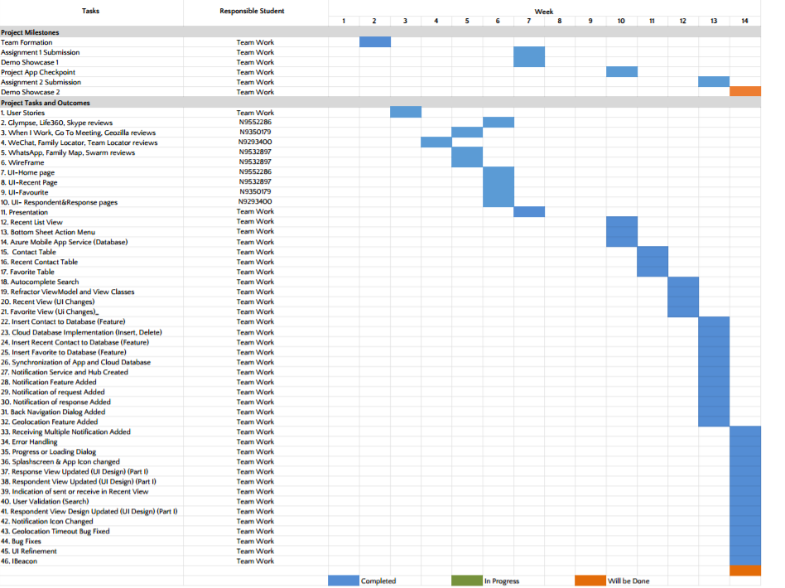

**List of Known Issues**

* Network Issue: As our application relies on internet service, we need internet to connect. Some pages take some time to load because of slow internet connection. This issue is solved by adding a loading spinner dialog which disappears when data is completed loaded. (Low severity issues)